Godrevy Class Homework Autumn 1st Half Term - year 3 and 4
After with previous years we have chosen to keep with the format used for homework and hope that it offers you opportunities to support core academic learning but also to be creative and have fun with learning. The tasks set are optional but it would be good to try at least one PSHE and Topic homework whilst reading remains the single most important thing you can do at home to support your child in school. The school now subscribes to Seesaw and sometimes teachers may suggest that you post your efforts for topic and Personal Moral Spiritual tasks on your journal otherwise bring them into school. The school continues to use the internet based maths resource, Mathletics, and has now also subscribes to Times Table Rockstars. You should have logins for both resources (obtainable from Mrs B or your class teacher). Occasionally teachers may choose to set tasks on Mathletics but if they do not you can practise maths of your choice and Times Table Rockstars is excellent for learning those all-important facts. Mathletics certificates and times table bands will be awarded in Friday Celebration assemblies. Teachers will also monitor children’s reading records and two children from each class will be selected at the end of term for a trip to Waterstones in Truro to choose a book that the school will pay for. We hope you have fun supporting learning at home and did I mention that reading is very important.

Reading. Remember reading is probably the most important homework you can do. Try and read every night even if it is just for 10 minutes. Sometimes it is also nice to have stories read to you. It is not the number of books you read that matters as some of you will be reading much longer books than others. The important things are that you understand what you are reading and enjoy what you are reading. If this is not the case speak to your teacher because they will do all they can to help you read together at home. You all have a reading record to track your reading so you don’t need to write anything here and teachers will now be choosing 2 children from each class every half term for the treat to head to Waterstones in Truro to choose a book the school will pay for.
Personal Moral Spiritual  Going for Goals | ish  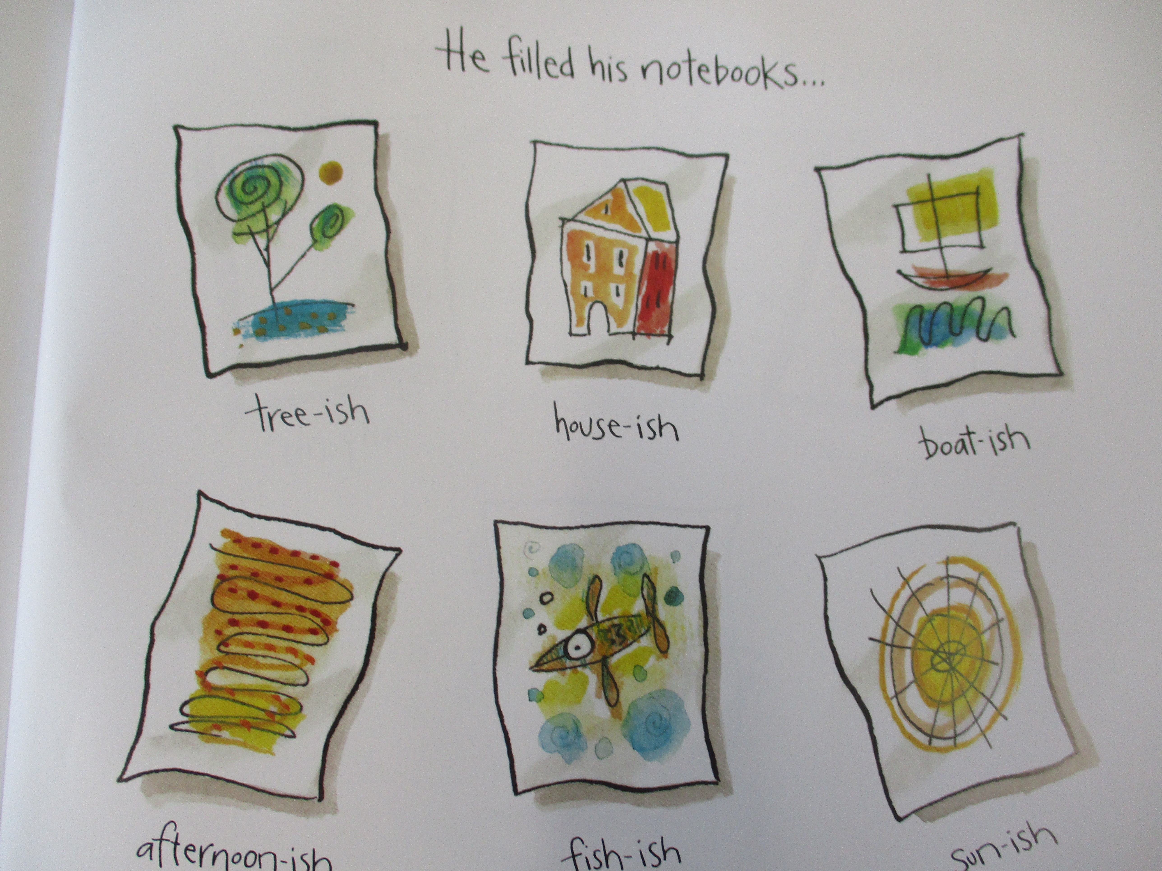  Instead of the story, The Dot we started our assemblies with the follow up story written by Peter Reynolds called ‘Ish’. The character in the book called Ramon draws lots of pictures after giving up painting because his sister likes them. Create your own collection of ‘ish’ pictures like I did for assembly. | 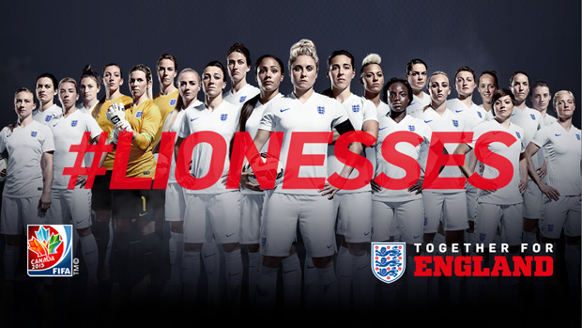  Unlikely Heroes  In assembly we spoke about how people have achieved goals and looked at theLionesses. They are one of the best teams in the world but lots of people didn’t think they would get far in this world cup due to injuries in the team and yet they made it to the final. Find a team or individual that has achieved goals against all odds and get a picture of them to show your class and tell their story. If you really want to you could make a powerpoint or write a report. | 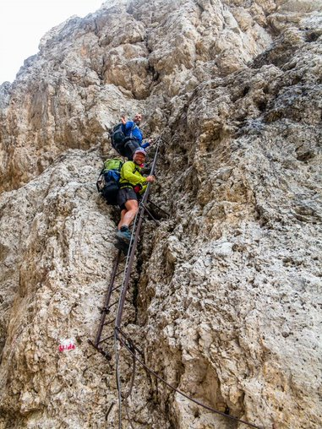  Something New!  Trying new things opens up new possibilities and with them come new challenges and goals. I had a go at Via Ferrata this summer which is like climbing I have done before but with cables and ladders. Get a picture or video of you trying something new and tell your class a little about your experience. | 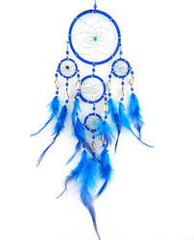  Goal or Dream?  What is the difference? In school we think of goals as something we can achieve in a short time but you should not stop dreaming. Maybe you want to play for England? Help lead and change the country? Be a famous musician? Go to the moon? Draw a picture of yourself in your dream future or make a dreamcatcher to hold your dream close to you there are lots of videos online to show you how like this one: DIY | How To Make A Dreamcatcher - YouTube
Our Topic  Myths and Magic | 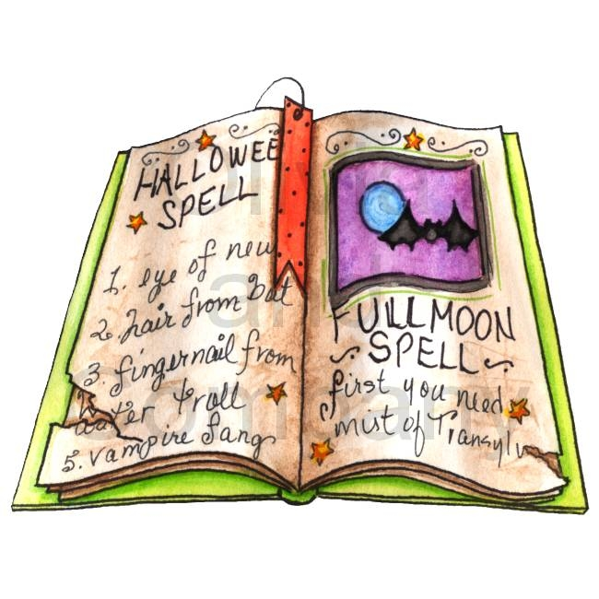  Writing- Create a book of spells  Can you create your own book of magical spells? Don’t forget to list the ingredients for each of your spells and the method so witches and wizards know how to make them. | Science/DT – make a light up wand or light saber  We are learning about light in science. Can you create your own magic wand or star wars style light saber that really lights up? You could use glow sticks or even electricity with wires and batteries. | History – learn about a Cornish Myth  Cornwall is full of myths and legends! Can you find out about a Cornish myth (eg merrymaid of Zennor, giant of St Agnes)? Create a poster or a powerpoint on the myth for us to display in our classroom to show the rest of the class. | Poetry – things found in a wizards pocket  Look up the poem ‘Ten things found in a wizard’s pocket’ for inspiration and create your own list of magical things you might find in a witch or wizard’s pocket!
Mathletics | The school has decided to continue to subscribe to mathletics and we also now have Times Table Rockstars.  Certificates awarded on Mathletics or Rockstars this term and Karate Bands achieved:
 | Comment

