Homework Spring 2nd Half Term Godrevy Class
After with previous years we have chosen to keep with the format used for homework and hope that it offers you opportunities to support core academic learning but also to be creative and have fun with learning. The tasks set are optional but it would be good to try at least one PSHE and Topic homework whilst reading remains the single most important thing you can do at home to support your child in school. The school now subscribes to Seesaw and sometimes teachers may suggest that you post your efforts for topic and Personal Moral Spiritual tasks on your journal otherwise bring them into school. The school continues to use the internet based maths resource, Mathletics, and has now also subscribes to Times Table Rockstars. You should have logins for both resources (obtainable from Mrs B or your class teacher). Occasionally teachers may choose to set tasks on Mathletics but if they do not you can practise maths of your choice and Times Table Rockstars is excellent for learning those all-important facts. Mathletics certificates and times table bands will be awarded in Friday Celebration assemblies. Teachers will also monitor children’s reading records and two children from each class will be selected at the end of term for a trip to Waterstones in Truro to choose a book that the school will pay for. We hope you have fun supporting learning at home and did I mention that reading is very important.

Reading. Remember reading is probably the most important homework you can do. Try and read every night even if it is just for 10 minutes. Sometimes it is also nice to have stories read to you. It is not the number of books you read that matters as some of you will be reading much longer books than others. The important things are that you understand what you are reading and enjoy what you are reading. If this is not the case speak to your teacher because they will do all they can to help you read together at home. You all have a reading record to track your reading so you don’t need to write anything here and teachers will now be choosing 2 children from each class every half term for the treat to head to Waterstones in Truro to choose a book the school will pay for.
Personal Moral Spiritual  Journeys  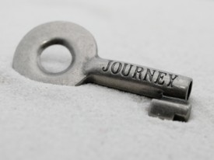 | 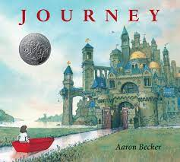  A Journey Story  We have previously looked at the book Journey by Aaron Becker. It is a beautiful book and I would advise any parent of young children to get a copy if you haven’t already.  Being able to tell a story with just pictures has to be a real challenge – do you think you could do it – we would love to see your efforts  If that is too daunting there are some easier tasks linked to the story that can be found using this link: aaronbecker_journey_trilogy_activity_kit.pdf (storybreathing.com) | Capture a Journey  The obvious journey homework is to go on one!! It can be as adventurous or as gentle as you like. It could also be familiar or one you have never done before. Your challenge is to capture a flavour of the jouney in six pictures – I’m currently taking a photography course so I’m going to try this one myself. I have attached an example from a previous trip across Spain. | Past Present Future  As we journey through life we are constantly changing. Some changes we have no control over (as my ever increasing wrinkle count reminds me in the bathroom mirror!). Others we can by making good choices, working hard and sometimes by taking risks. How were you different in the past? What can you do now that you could not do then? What do you want to become in the future? Talk with parents and maybe write 3 lists, draw 3 pictures or make a Venn diagram to compare the ‘3 Yous’. | Travelling together:  We have done this before but you can’t have too much kindness in the world so let’s go again: What makes someone a good friend to travel with? All friends like to feel valued so make something for a friend; it could be a bracelet (this link shows how to make a tricky one how to make a friendship bracelet - Google Search) or something else you know they would like to remind them of how close you are. It means so much more if you make it though.
 | Comment | Comment | Comment | Comment
Our Topic  Romans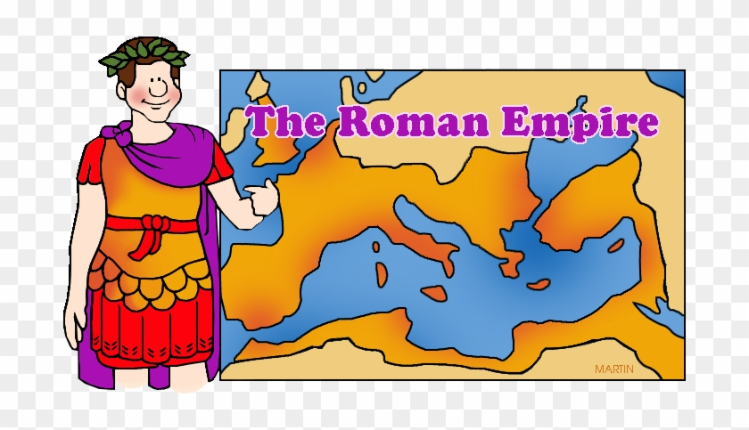 | Make a Volcano  We will be learning about the eruption of the stratovolcano Mount Vesuvius in the Roman town of Pompeii in 79AD. For your geography homework task can you make a model of a volcano? It could be a drawing of a cross section or a 3D model. Please include some labels on your model and some information about how volcanoes erupt. | DT - 3D boxes.  We will be learning about how 3D structures are made and will be building a ‘toy with a hidden compartment’ inspired by the trojan horse story. I know some of you creative types are itching to have a go at this at home so here is your homework task; build your own toy with a secret compartment! | Literacy - diary writing.  In literacy we are writing diaries as if we were Romans. I would love to read some of your creative writing from home. Write me a diary of either: Your weekend, an activity or sporting event you have been to, your favorite day at school, a 'day in the life' from the point of view of your pet or you could invent your own diary entry from the point of view of a Roman. | Roman architecture  The Romans are well renowned for their temples, aqueducts, public baths, roads and Colosseums. Can you make a poster about Roman architecture to put on our homework display?
 | Comment | Comment | Comment | Comment
Mathletics | The school has decided to continue to subscribe to mathletics and we also now have Times Table Rockstars.  Certificates awarded on Mathletics or Rockstars this term and Karate Bands achieved:
 | Comment

